**Business problem**

Create a model that tells us which add (from 10) should a company post on a social network.

**Explaining the model**

1. Import the dataset, which is in a csv format.
2. We use the columns of interest, which are the annual income and spending.
3. Since there is no package for the UCB, we need to create it manually. We start by creating a vector that has the number of times the add i was selected until round n (in the first round there was no add selected, so we create a vector of zeros). Since there are no initial selections, the sum of rewards is also zero at the beginning. Then, we need to create as many rounds as rows, because we need to know for each person on our dataset, what was the result of showing all adds (two for loops, one for each person – total 10000, and the other for each add – total 10). Finally, we need to create a vector that has all the version of the adds selected at each round.
4. After that, we plot the graph.

**Plotting the results**

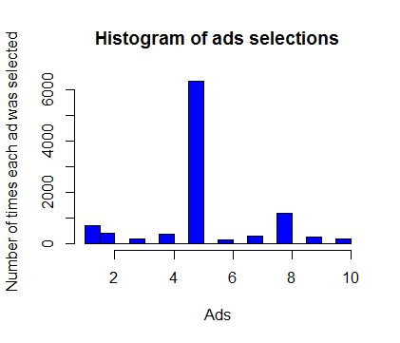

As we can see, the add with the most conversion rate is the add number 5.